AI ASSISSTED CODING LAB – 9.1
Documentation Generation -Automatic
documentation and code comments
NAME : J.SANJANA
ROLL_NO : 2503A52379
Problem 1 :
Consider the following Python function:
def find_max(numbers):
return max(numbers)
Task :
• Write documentation for the function in all three formats:
(a) Docstring
(b) Inline comments
(c) Google-style documentation

Week5 -
Monday

• Critically compare the three approaches. Discuss the
advantages, disadvantages, and suitable use cases of each
style.
• Recommend which documentation style is most effective
for a mathematical utilities library and justify your
answer.
PROMPT :
Document the Python find_max() function using docstring, inline comments, and Google-style documentation. Briefly compare all three and recommend the best option for a math utility library.
INPUT CODE :
def find_max(numbers):
return max(numbers)
(a) Docstring
def find_max(numbers):
"""Return the largest value from a collection of numbers."""
return max(numbers)
(b) Inline Comments
def find_max(numbers):
# Find and return the largest number in the given collection.
return max(numbers)
(c) Google-Style Documentation
def find_max(numbers):
"""Find the largest value in a collection of numbers.

Args:
numbers (list): A collection of numbers from which to find
the maximum value.

Returns:
The largest value in the collection.

Raises:
ValueError: If the collection is empty.
TypeError: If the input is not suitable for the max() function.
"""
return max(numbers)
Expected Output :
COMPARISION :
Feature | Docstring | Inline Comments | Google-Style
Ease of writing | Very easy | Very easy | Moderate
Explains function purpose | Yes | Yes | Yes
Documents parameters | Limited | Limited | Excellent
Documents return values | Limited | Limited | Excellent
Documents exceptions | Limited | Limited | Excellent
Available through help() | Yes | No | Yes
Useful for complex implementation | Limited | Excellent | Moderate
Suitable for libraries | Good | Limited | Excellent
Supports automated documentation | Yes | Generally no | Excellent
Verbosity | Low | Low–moderate | High

Problem 2 :
Consider the following Python function:
def login(user, password, credentials):
return credentials.get(user) == password
Task :
1. Write documentation in all three formats.
2. Critically compare the approaches.
3. Recommend which style would be most helpful for new
developers onboarding a project, and justify your choice.
PROMPT :
Document the Python login() function using docstring, inline comments, and Google-style documentation. Compare the three briefly and recommend the best style for new developers joining a project.
INPUT CODE :
def login(user, password, credentials):
return credentials.get(user) == password
(a) Docstring
def login(user, password, credentials):
"""Check whether the user's password is correct."""
return credentials.get(user) == password

credentials = {
"sanju": "1234",
"admin": "admin123"
}

print(login("sanju", "1234", credentials))
print(login("sanju", "wrong", credentials))
(b) Inline Comments
def login(user, password, credentials):
# Get the stored password for the user
# and compare it with the given password.
return credentials.get(user) == password

credentials = {
"sanju": "1234",
"admin": "admin123"
}

print(login("sanju", "1234", credentials))
print(login("admin", "wrong", credentials))
(c) Google-Style Documentation
def login(user, password, credentials):
"""Check user credentials.

Args:
user (str): Username.
password (str): Password provided by the user.
credentials (dict): Stored usernames and passwords.

Returns:
bool: True if the password matches, otherwise False.
"""
return credentials.get(user) == password

credentials = {
"sanju": "1234",
"admin": "admin123"
}

print(login("sanju", "1234", credentials))
print(login("admin", "wrong", credentials))
Expected Output :
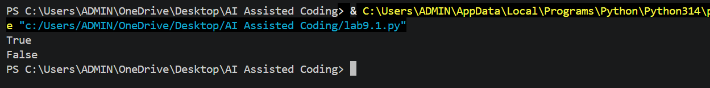
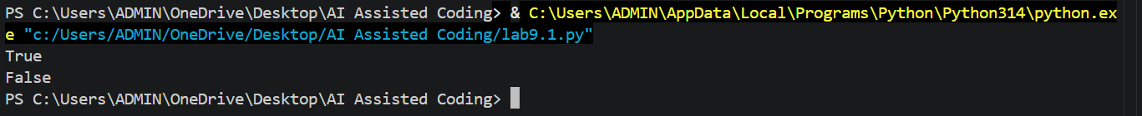
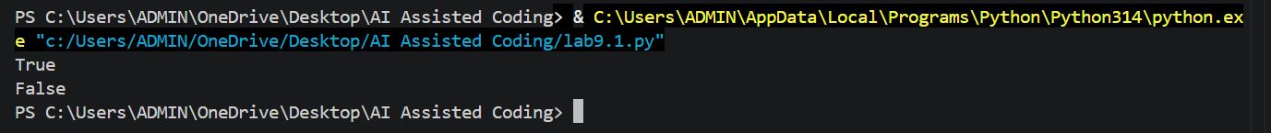
COMPARISION :
Style | Advantages | Disadvantages
Docstring | Simple, readable, available with help() | May not provide enough details
Inline Comments | Easy to understand the code logic | Can become outdated and are not formal documentation
Google-Style | Clear structure; explains inputs and outputs | More detailed and takes more time to write

Problem 3 :
Calculator (Automatic Documentation Generation)
Task:
Design a Python module named calculator.py and
demonstrate automatic documentation generation.
Instructions:
1. Create a Python module calculator.py that includes the
following functions, each written with appropriate docstrings:
o add(a, b) – returns the sum of two numbers
o subtract(a, b) – returns the difference of two numbers
o multiply(a, b) – returns the product of two numbers
o divide(a, b) – returns the quotient of two numbers
2. Display the module documentation in the terminal using
Python’s documentation tools.
3. Generate and export the module documentation in HTML

format using the pydoc utility, and open the generated HTML
file in a web browser
PROMPT :
Create a Python module calculator.py with add, subtract, multiply, and divide functions using docstrings. Show the documentation in the terminal using pydoc, generate calculator.html, and explain how to open it in a browser.
INPUT CODE :
"""
Calculator Module

This module provides basic arithmetic operations.
"""

def add(a, b):
"""Return the sum of two numbers."""
return a + b

def subtract(a, b):
"""Return the difference between two numbers."""
return a - b

def multiply(a, b):
"""Return the product of two numbers."""
return a * b

def divide(a, b):
"""Return the quotient of two numbers."""
return a / b

# Test the functions
if __name__ == "__main__":
print("Addition:", add(10, 5))
print("Subtraction:", subtract(10, 5))
print("Multiplication:", multiply(10, 5))
print("Division:", divide(10, 5))
1.Run the Python file
py calculator.py
2.Display Documentation in Terminal
py -m pydoc calculator
3. Generate HTML Documentation
py -m pydoc -w calculator
Expected Output :
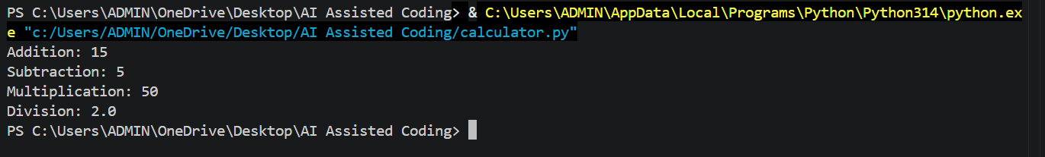
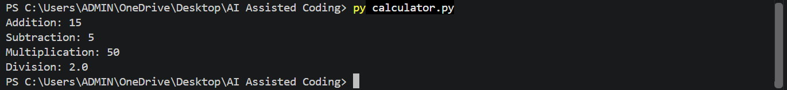
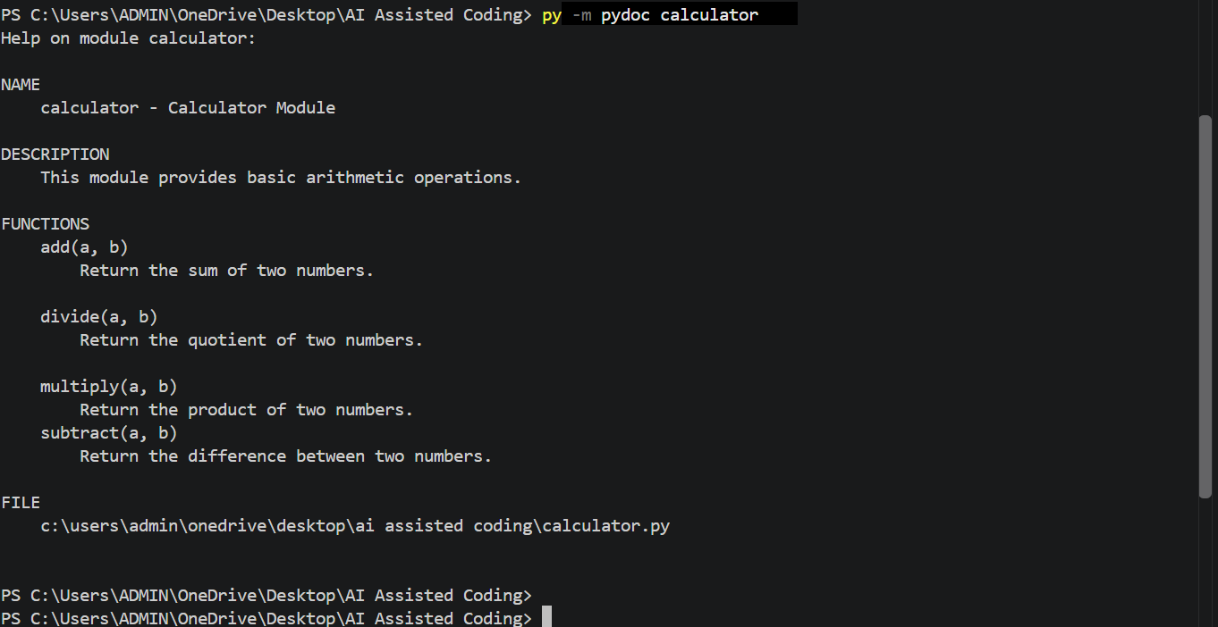
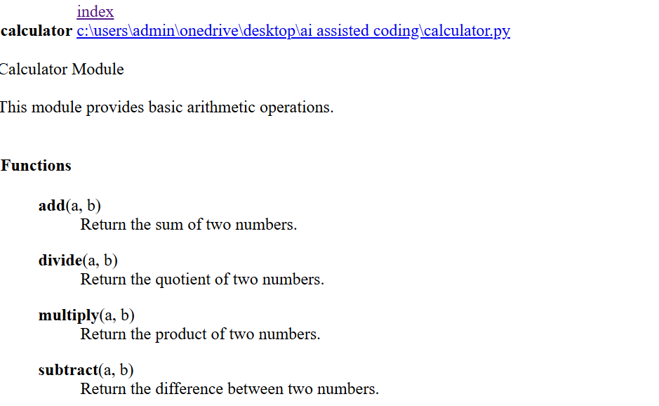
Problem 4 :
Conversion Utilities Module
Task :
1. Write a module named conversion.py with functions:
o decimal_to_binary(n)
o binary_to_decimal(b)
o decimal_to_hexadecimal(n)
2. Use Copilot for auto-generating docstrings.
3. Generate documentation in the terminal.
4. Export the documentation in HTML format and open it in a
browser.
PROMPT :
Create a Python module conversion.py with decimal-to-binary, binary-to-decimal, and decimal-to-hexadecimal functions. Use Copilot to generate docstrings, display documentation using pydoc, and generate and open the HTML documentation.

INPUT CODE :
"""
Conversion Utilities Module

This module provides functions for converting decimal numbers
to binary and hexadecimal, and binary numbers to decimal.
"""

def decimal_to_binary(n):
"""Convert a decimal number to binary."""
return bin(n)[2:]

def binary_to_decimal(b):
"""Convert a binary number to decimal."""
return int(b, 2)

def decimal_to_hexadecimal(n):
"""Convert a decimal number to hexadecimal."""
return hex(n)[2:]

# Test the functions
if __name__ == "__main__":
print("Decimal to Binary:", decimal_to_binary(10))
print("Binary to Decimal:", binary_to_decimal("1010"))
print("Decimal to Hexadecimal:", decimal_to_hexadecimal(10))
1. Use Copilot
def decimal_to_binary(n):
"""Convert a decimal number to its binary representation."""
return bin(n)[2:]

2. Generate Documentation in Terminal
Run:
py -m pydoc conversion
3. Generate HTML Documentation
py -m pydoc -w conversion
Expected Output :
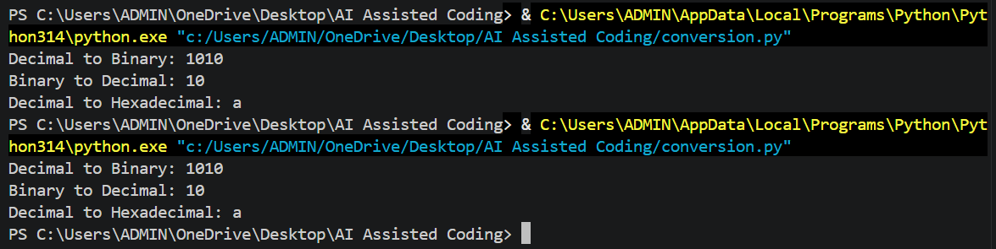
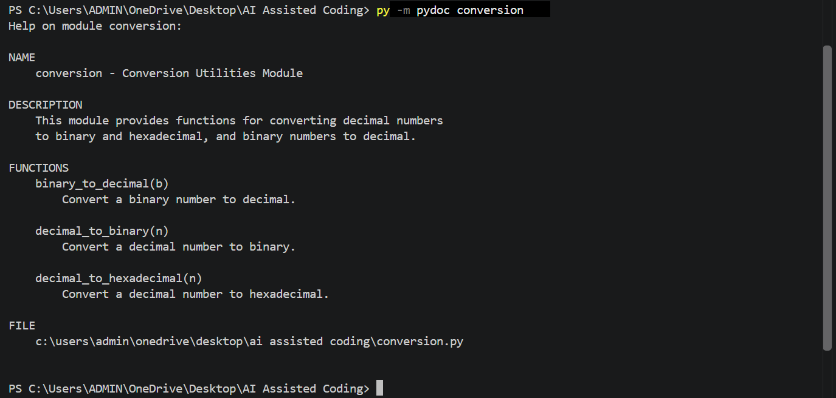
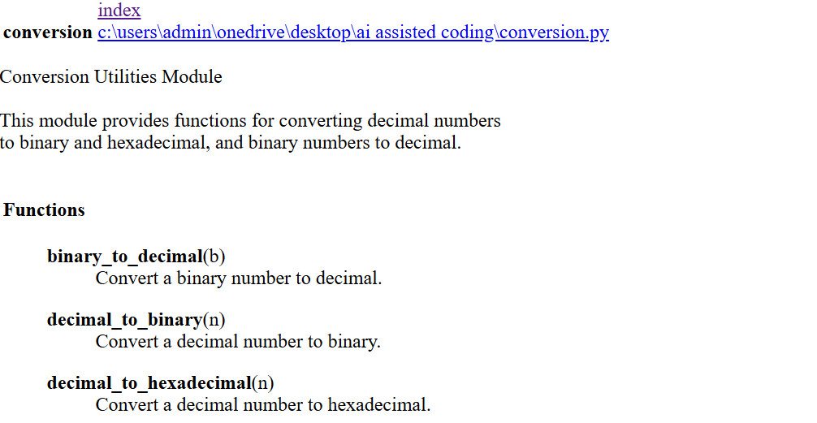
Problem 5 –
Course Management Module
Task :
1. Create a module course.py with functions:
o add_course(course_id, name, credits)
o remove_course(course_id)
o get_course(course_id)
2. Add docstrings with Copilot.
3. Generate documentation in the terminal.
4. Export the documentation in HTML format and open it in a
PROMPT :
Create a Python course.py module with add_course(), remove_course(), and get_course() functions. Use Copilot to generate docstrings, display the documentation using pydoc, and generate and open the HTML documentation.
INPUT CODE :
"""
Course Management Module

This module provides functions to add, remove,
and retrieve courses.
"""

courses = {}

def add_course(course_id, name, credits):
"""Add a new course to the course list.

Args:
course_id (str): Unique ID of the course.
name (str): Name of the course.
credits (int): Number of credits for the course.

Returns:
str: Message indicating that the course was added.
"""
courses[course_id] = {
"name": name,
"credits": credits
}
return "Course added successfully."

def remove_course(course_id):
"""Remove a course using its course ID.

Args:
course_id (str): ID of the course to remove.

Returns:
str: Message indicating whether the course was removed.
"""
if course_id in courses:
del courses[course_id]
return "Course removed successfully."
return "Course not found."

def get_course(course_id):
"""Retrieve course information using its course ID.

Args:
course_id (str): ID of the course to retrieve.

Returns:
dict or str: Course details or a not-found message.
"""
return courses.get(course_id, "Course not found.")

# Test the functions
if __name__ == "__main__":
print(add_course("CS101", "Python Programming", 4))
print(add_course("MA101", "Mathematics", 3))

print("Course:", get_course("CS101"))

print(remove_course("MA101"))

print("Course:", get_course("MA101"))
2.Use Copilot
"""Add a new course to the course list.

Args:
course_id (str): Unique ID of the course.
name (str): Name of the course.
credits (int): Number of credits for the course.

Returns:
str: Message indicating that the course was added.
"""
3. Generate Documentation in Terminal
py -m pydoc course
4. Generate HTML Documentation
py -m pydoc -w course
Expected Output :
